**Project Name:**

Git Workflow with Merge Conflicts

**Problem Statement:**

learn how to use Git and gain an understanding of its workflow by creating a repository, adding files, committing changes, pushing changes to a remote repository, cloning a repository, stashing changes, popping, rebasing, checking out branches, merging branches, and resolving merge conflicts.

1. Create a new repository on GitHub with the name “git-workflow-merge-conflicts”

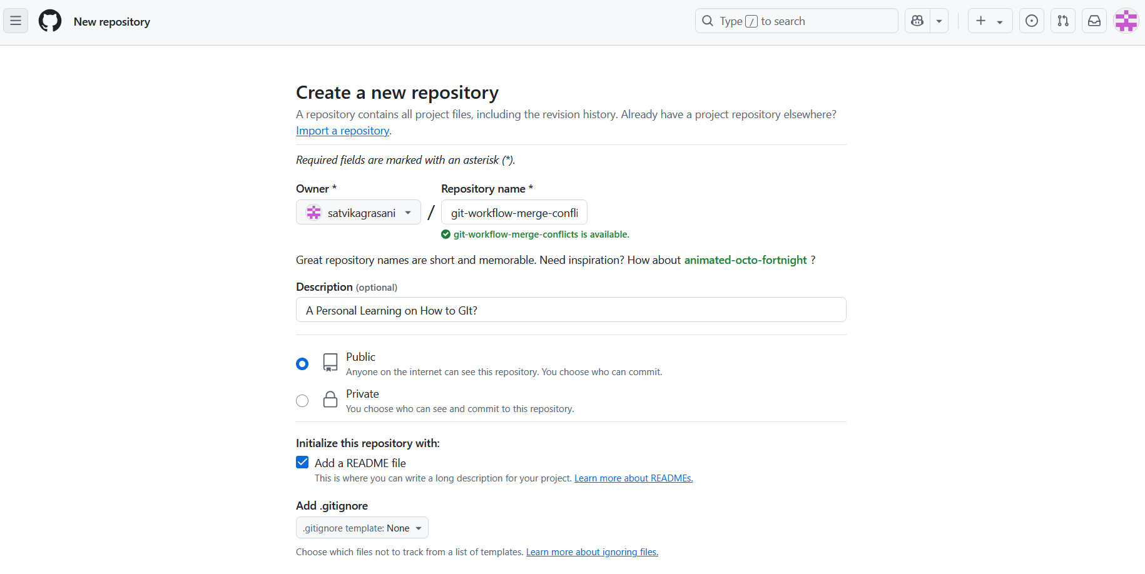

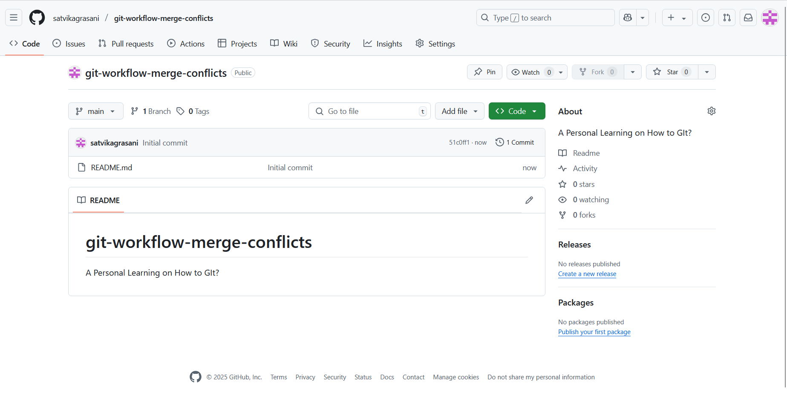

2. Clone the repository to your local machine using the “git clone” command.

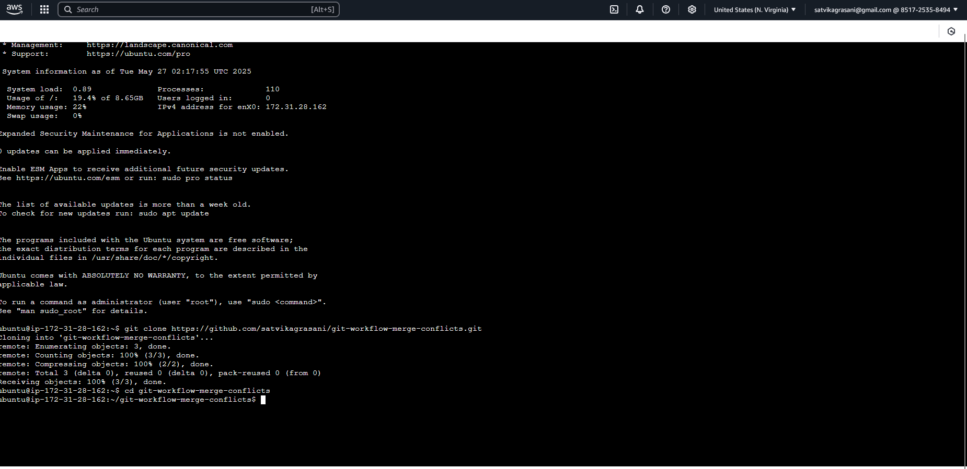

3. Create a new branch named “feature” and switch to it.

4. Create a new file named “feature.txt” in the repository.



5. Add some text to the “feature.txt” file.



6. Stage and commit your changes using Git.

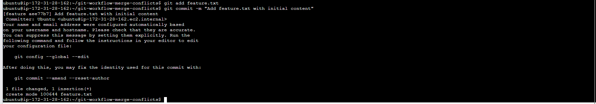

7. Push your changes to the “feature” branch on the remote repository on GitHub.

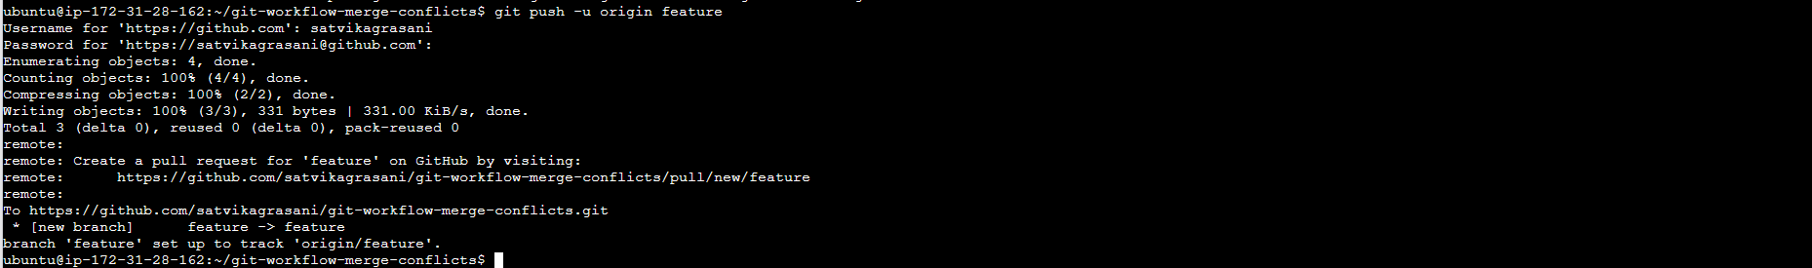

8. Create a pull request to merge the “feature” branch into the “main” branch.

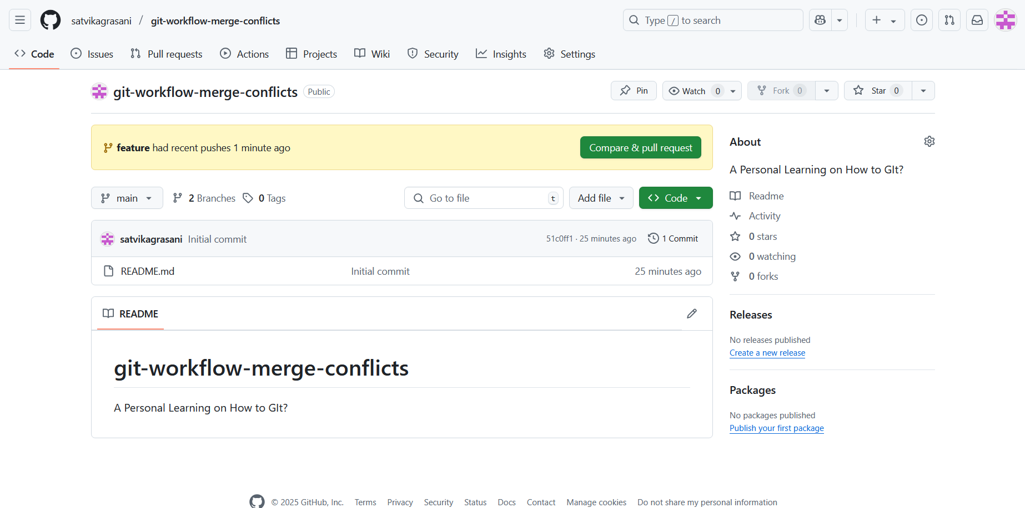

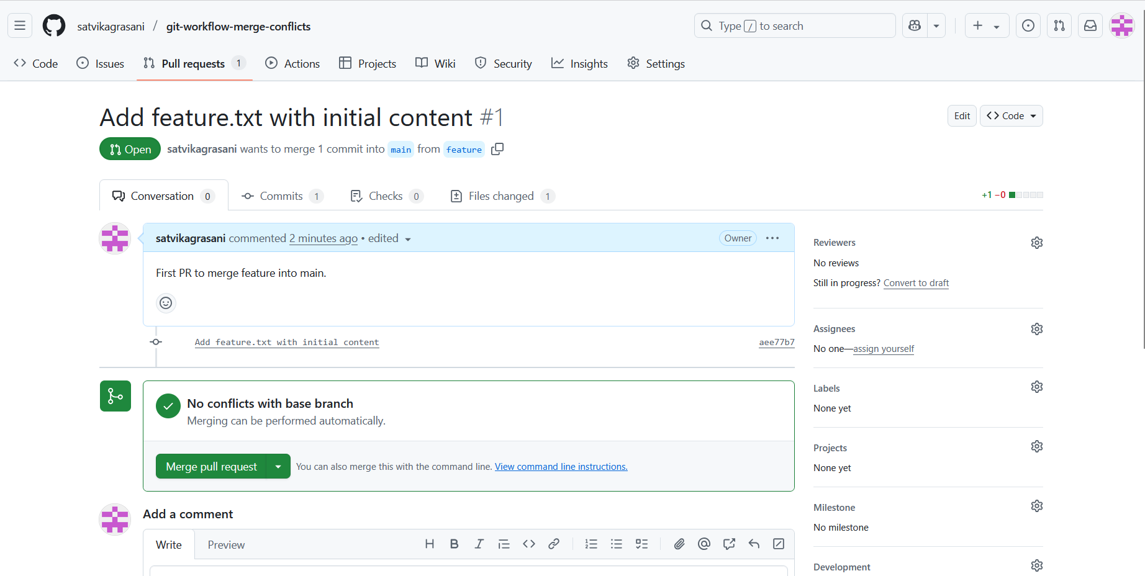

9. Switch back to the “main” branch.



10. Make some changes to the “README.md” file in the “main” branch.



11. Stage and commit your changes using Git.

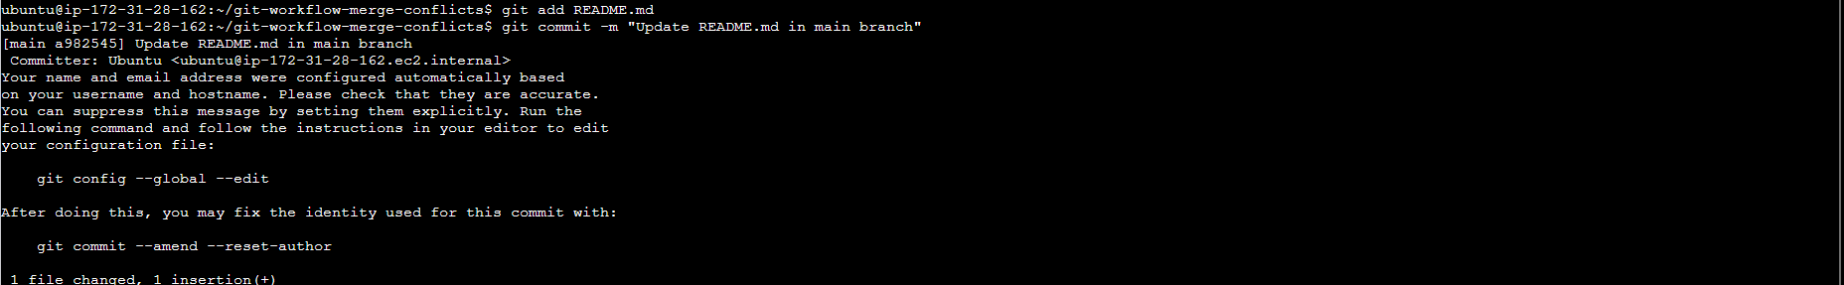

12. Push your changes to the remote repository on GitHub.

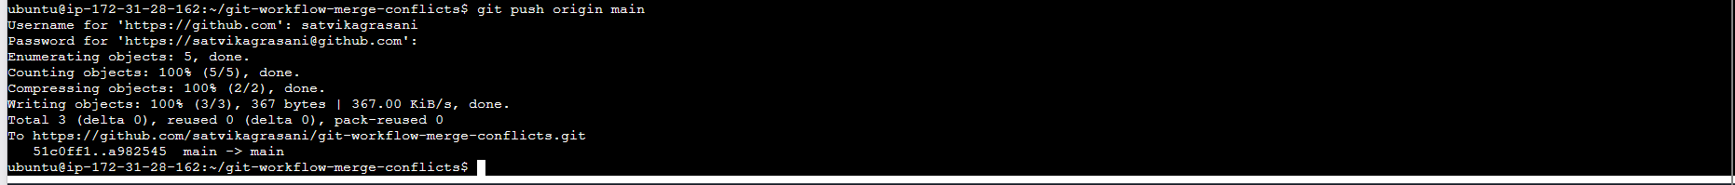

13. Merge the “feature” branch into the “main” branch.

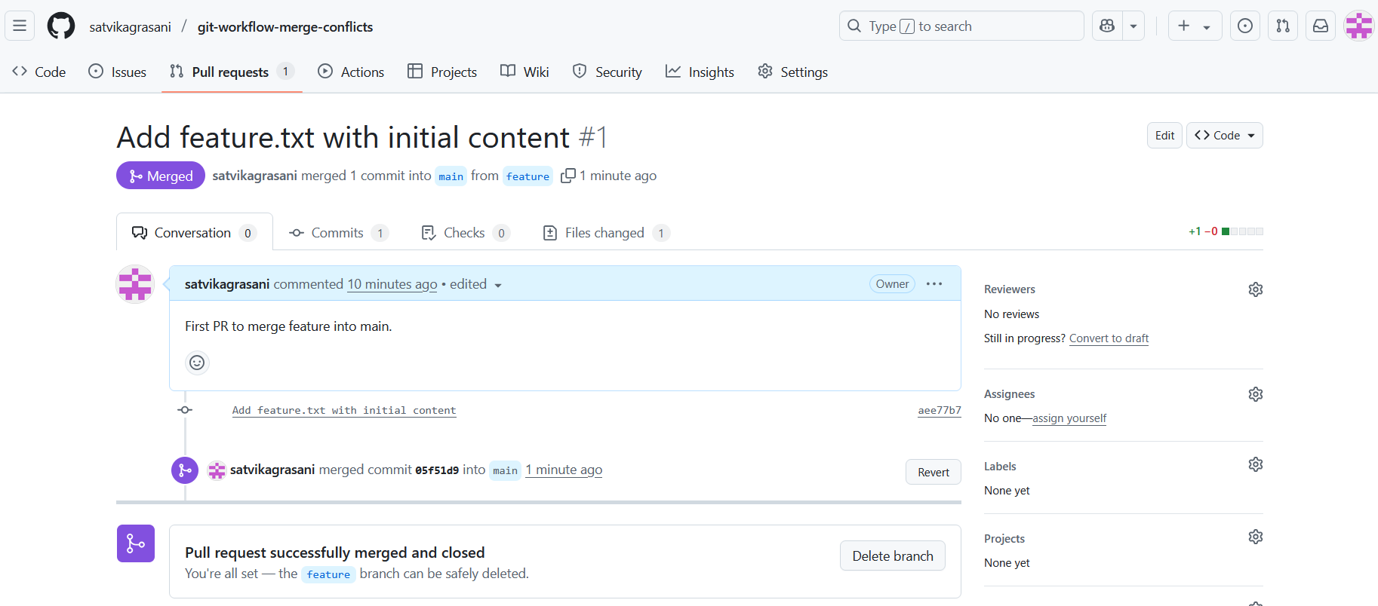

14. Create a new branch named “fix” and switch to it.



15. Make some changes to the “feature.txt” file in the “fix” branch.



16. Stage and commit your changes using Git.



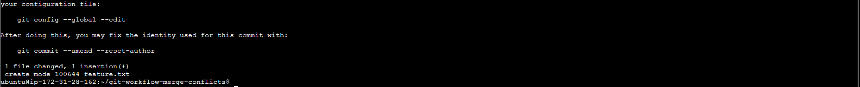

17. Switch back to the “main” branch.



18. Make some changes to the “feature.txt” file in the “main” branch.



19. Stage and commit your changes using Git. 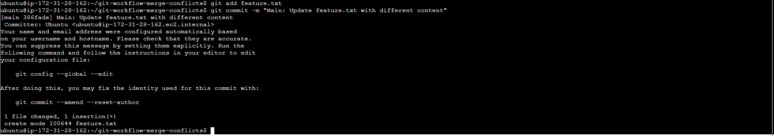

20. Try to merge the “fix” branch into the “main” branch.



21. Resolve the merge conflicts.

Note: Manually deleted conflict markers (<<<<<<<, =======, >>>>>>>) from features.txt

22. Stage and commit your changes using Git.

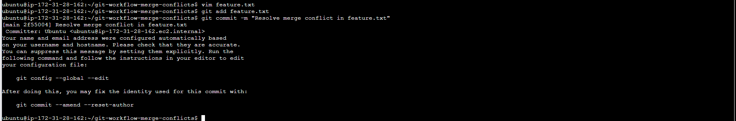

23. Push your changes to the remote repository on GitHub.

